[](http://www.google.co.nz/url?sa=i&rct=j&q=&esrc=s&source=images&cd=&cad=rja&uact=8&ved=0ahUKEwjE2_aJ8N3QAhVCKZQKHfEjBz4QjRwIBw&url=http://www.medtechglobal.com/managemyhealth-usa/&psig=AFQjCNHXItbEwKym8i43oNoSeEi41DRO-Q&ust=1481055552838813)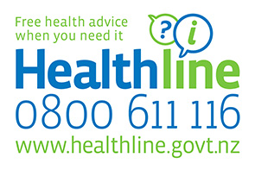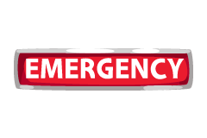



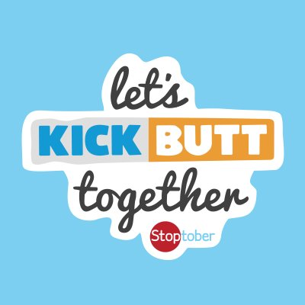

**Stoptober quit smoking challenge**

Stoptober NZ is a fun stop smoking challenge for anyone thinking about ‘kicking butt’.

For more information visit <http://www.smokefree.org.nz/> or talk with one of our nurses today for smoking cessation support.

**October is breast awareness month**

Breast cancer is New Zealand’s third most common cancer and accounts for more than 600 deaths every year. A mammogram is a safe, low-dose x-ray of the breast that can pick up very small breast cancers, well before a lump can be felt.

BreastScreen Aotearoa is a free national breast screening programme. You can have a free mammogram every two years through BreastScreen Aotearoa from aged 45 to 69.

Phone 0800 270 200 or visit [www.breastscreen.govt.nz](http://www.breastscreen.govt.nz) for more information.

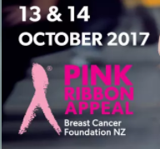

**Contact Details**

Please ensure your contact details including email and mobile phone number are up to date. This is important as we now have the facility to email invoices. We also text to remind of upcoming appointments as well as notifying when prescriptions are ready.

**Manage My Health**

Spring Newsletter 2017

www.cmed.co.nz

**Free Wi-Fi** We now have free

Wi-Fi in the waiting room.

**Repeat Prescription Requests**

You can now order a repeat prescription from our website [www.cmed.co.nz](http://www.cmed.co.nz) or via the Manage My Health patient portal.

Please ensure you give us your full name, date of birth, repeat medication and advise how your wish to collect. If you require your script to be faxed to a pharmacy, advise Pharmacy details.

**Changes to our Team**

We would like to welcome Dr Vanessa Souter and Dr Debbie Taylor to our clinical team along with practice nurse Alana. We also welcome Jenny to our reception team.

<http://www.getthru.govt.nz>

**Our website**

Check out our website [www.cmed.co.nz](http://www.cmed.co.nz)

Please visit and have a look. You can order a repeat prescription, download our travel consultation form, see our wide range of services and find out about our latest news and health items of interest.



**Primary healthcare nursing services**

Talk to our dynamic team of nurses who offer a wide range of services to assist with your ongoing healthcare and wellbeing.

Ask at reception if you would like to find out more and book your nurse appointment.

**Manage My Health**

We have received good feedback with regard to our patient portal ‘Manage My Health’. Patients are enjoying the ability to book appointments online as well as ordering repeat prescriptions.

If you are not already registered and wish to enjoy the benefits the patient portal offers contact reception on [reception@cmed.co.nz](mailto:reception@cmed.co.nz) or phone 04 801 5228 for further details.

We are on Facebook. Like our page and find out what’s happening at Courtenay Medical.

[](https://www.google.co.nz/url?sa=i&rct=j&q=&esrc=s&source=images&cd=&cad=rja&uact=8&ved=0ahUKEwiNlPO6m7TTAhVBj5QKHZOkAYIQjRwIBw&url=https://developers.facebook.com/&psig=AFQjCNGTAl1-4oo7CcMEqjFCkeHRO_dc6g&ust=1492818231029734)



**When we are closed…**

You can seek medical attention at: Wellington Accident & Urgent Medical Centre, 17 Adelaide Rd, Newtown, Wellington (04) 384-4944 Open every day 8am-11pm

Or between the hours of 11pm—8am Wellington Hospital Emergency Department, Riddiford St, Newtown, Wellington.

Or Phone Healthline on 0800 611 116

www.cmed.co.nz

Spring Newsletter 2017